DAD 220 Project Two Template

Overview
Review the scenario for this activity in the guidelines and rubric. Then complete the steps below as you work through the directions for this activity. Replace the bracketed text with your screenshots and responses to the prompts. Size each screenshot and its explanation to fit approximately one-quarter of the page with the description written below the screenshot. Review the Template Screenshot Example linked in the guidelines and rubric for this assignment to see an example of how screenshots for your assignment should look.

RMA Report
Write a report to respond to the manager’s requests. In the report, you should complete the following actions:

- Summarize the data you’ve been working with.
- Identify key information that will help the company streamline operations.

Your report should explain your findings in a way nontechnical stakeholders can understand and use.

Use the steps below to capture the required data and produce the analysis report.

- Begin by writing SQL commands to capture specific usable data for your analysis. You already preloaded the data you need into Codio.

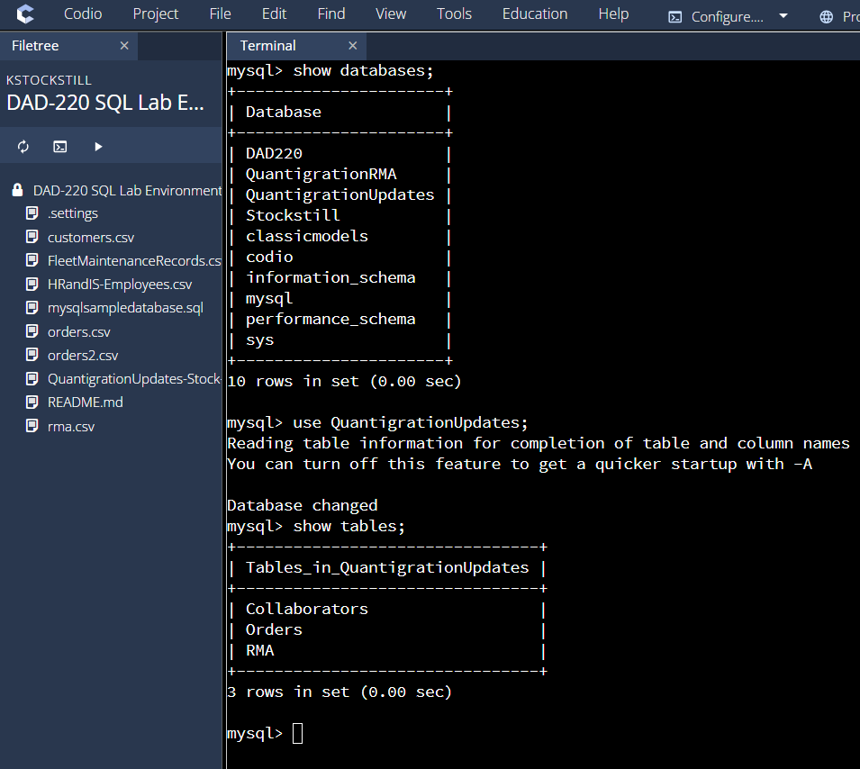

- Specifically, the product manager wants you to complete the following analysis:

  - Analyze the number of returns by state and describe findings to include in your report.

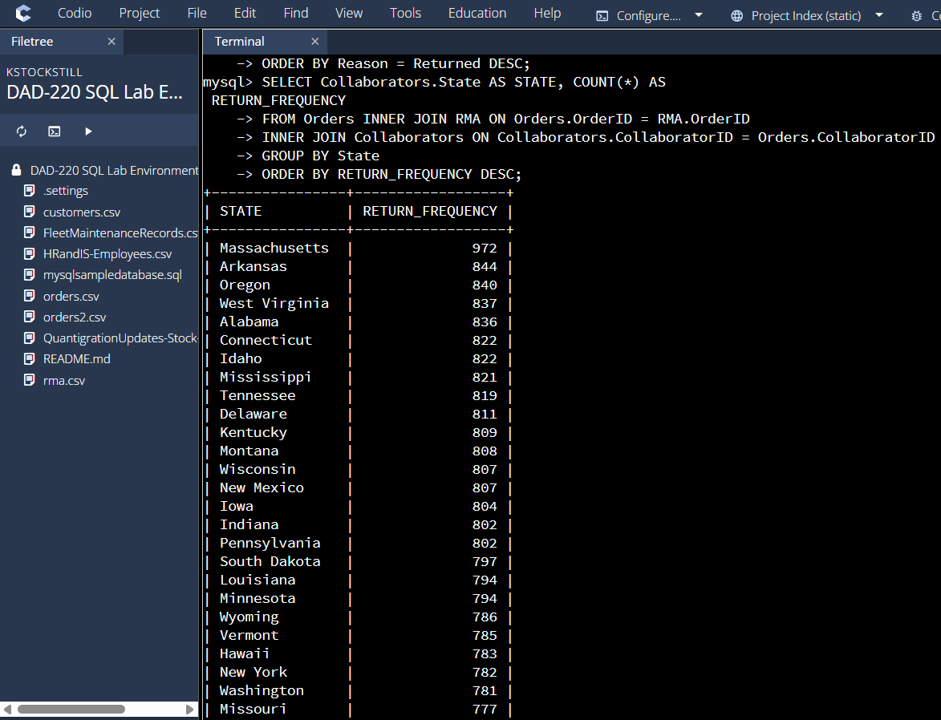

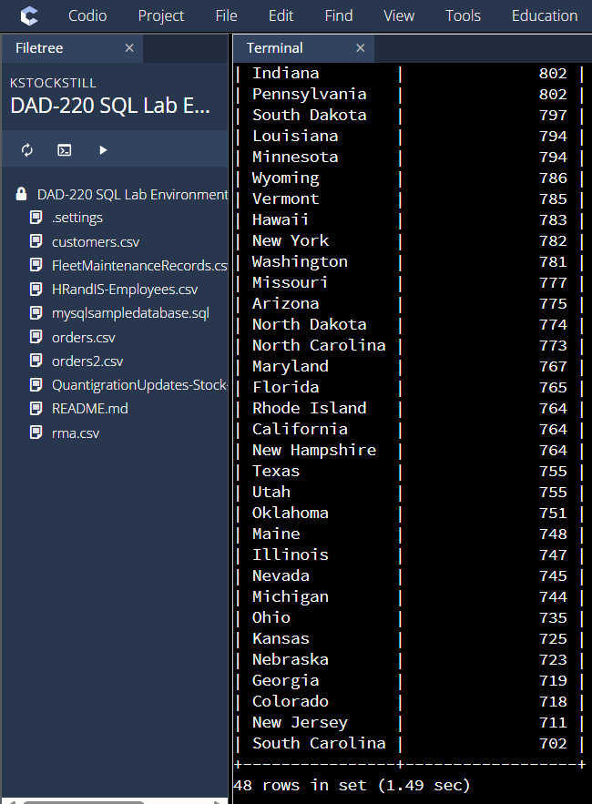

From this analysis I can conclude that the state of Massachusetts has the most returns of 972, showing a significant jump from the other states.

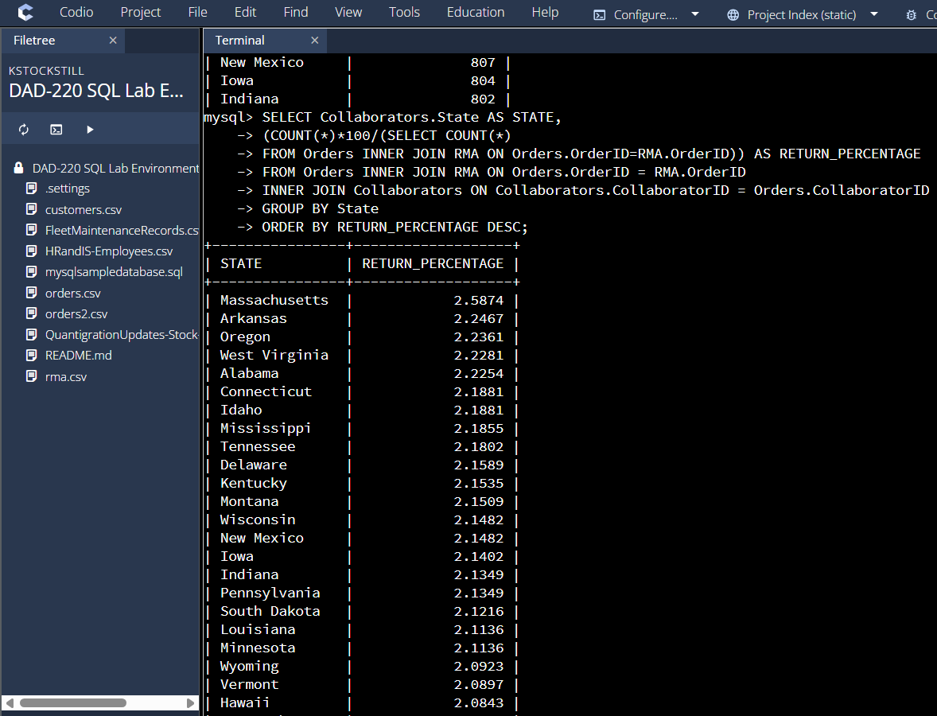
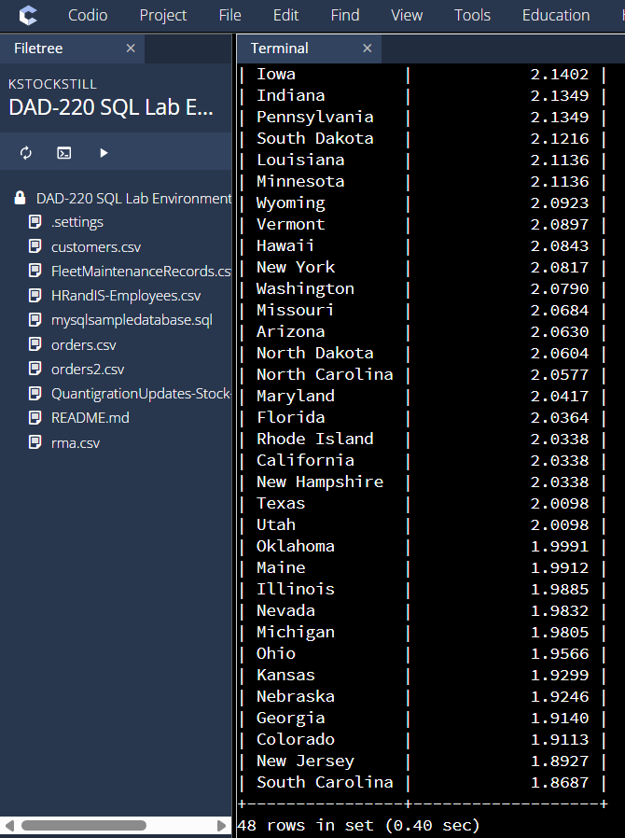

Seeing that Massachusetts has the highest returns I looked at the percentage overall compared to the other states. Massachusetts has a return percentage of 2.58%.
  - Analyze the percentage of returns by product type and describe findings to include in your report.

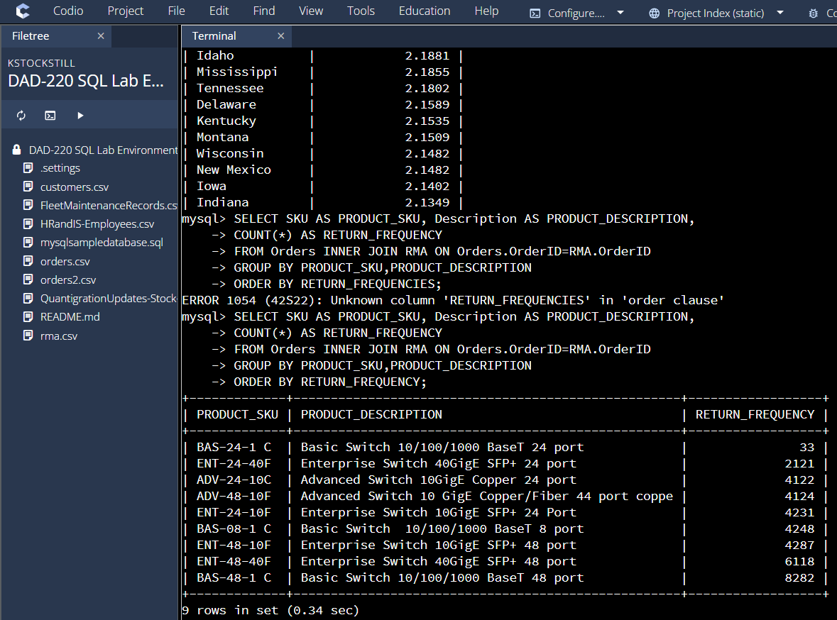

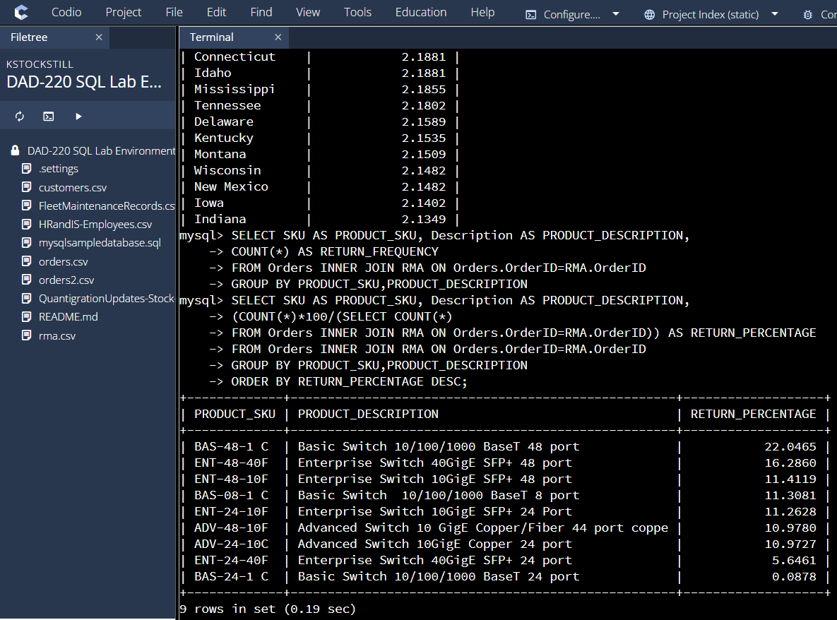
From these two inquiries, you can see that the Basic Switch 10/100/1000 BaseT 48 port has the highest returns of 8282 with a percentage return of 22.046%

- Write a report to clearly summarize your RMA data analysis for stakeholders. When you summarize the results, consider the following questions:

  - How does the data provide the product manager with usable information?
  - What are the potential flaws in the data that has been presented?
  - Are there any limitations on your conclusions or any other ways of looking at your findings that you haven’t considered? Clearly communicate your findings to stakeholders.

The data provided can give the product manager insight into the frequency of returns occurring in each state as well as the return percentages of products provided. By looking at this data it is easy to designate which states and products are bringing in the highest returns. The data has been processed to show exactly what the product manager is looking for, the states and their return values and the products with the highest return values, this leaves the task simple to identify.

There is room for potential flaws alongside this data. Some that can occur in making this data inaccurate is that the system is not updated, and certain numbers not yet processed into the main database. There is always concern about inputting the wrong type data for the product, it may not have been returned but just exchanged. This could leave the state showing a higher return value.

From this analysis you can see that the state of Massachusetts is bringing in the highest return value of 972 returns giving the state a return percentage of 2.58%. When you compare Massachusetts to the second state of highest returns Arkansas with 844 returns and a percentage of 2.25%, you can see a significant jump and difference in values. This should be looked at to see if there is a way to help bring the state of Massachusetts down to at least a level that is not such a jump from other states.

This analysis also shows that the most returned product is the Basic Switch 10/100/1000 BaseT 48 port with a total amount returned of 8282 and total percentage of 22.046%. If you compare these results to the 2nd most returned, you can again see with the state inquiries that the jump is significantly high. When looking closely at the analysis and comparing the most returned to the least returned you can see that the most returned is the Basic Switch 10/100/1000 BaseT 48 port and the least returned is the Basic Switch 10/100/1000 BaseT 24 port. Seeing that these are the same type of product but with a different port could be something to investigate. Why is one being returned more and how can we fix it to that both can have the same return percentage.

With this information provided I would suggest looking more deeply into the reason for return on the product Basic Switch 10/100/1000 BaseT 48 port and looking into what can be done to improve that item. Also seeing if that product is being exchanged for a certain product and investigate why that is being done. Another suggestion would be to investigate the highest return state of Massachusetts and see if they bring a high return value on the same Basic Switch that is being returned the most. From this data you can form a plan to find more detailed data on the highest state to show specifically what and how many products are being returned. Take note if there is a way to help bring the return percentages down from that one state alone that can then give a higher revenue and less return value.

